EVERBUILD AMERICAN DUCT TAPE

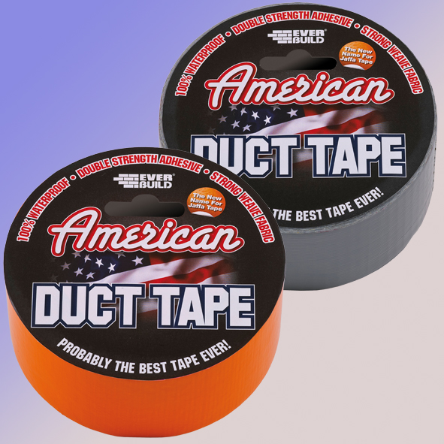

Colour | Product Code | Pack Size | Box Qty
orange | USDUCT0G25 | 50mm x 25Mtr | 12
 | USDUCTOG5 | 50mm x 5Mtr | 48
silver | USDUCTSV25 | 50mm x 25Mtr | 12

Product Description
American Duct Tape is a remarkable new tape which is not only thick, strong and 100% waterproof; it also has the most amazing adhesive quality.
American Duct Tape has a multitude of uses including waterproofing and windproofing scaffolding, windows, doors and exposed roofing – it can also be used on vertical and overhead applications due to its unique hold strength. You can also use American Duct Tape to temporarily hold DPM, timber, guttering, sheet material or any other building material that needs to be held in place without the need to clamp. American Duct Tape will stick to most surfaces and substrates and can be used internally as well as externally.

Benefits
- Will stick to most common surfaces including polythene.
- Stronger than standard Gaffa tapes.
- Waterproof.
- Bright Orange for easy recognition.

Limitations
- Do not use on surfaces that bleed oils or plasticisers
- It is the user’s responsibility to determine suitability for use. If in doubt contact technical services for advice.

Application
Ensure surfaces to which tape is to be applied are clean sound and dry. Remove outer packaging from roll of tape. Peel required amount of tape from roll pressing firmly into place while unrolling. Tear off or cut with a knife when finished.

Specific Data
Adhesive | Calendered Natural Rubber
Thickness | 0.19mm
Tensile Strength | 35 N/cm
Adhesion To Steel | 5.0 N/cm
Service Temp | -10 to +60°C

Storage
Store in cool dry conditions between 5 and 25⁰C. Safe in normal use however as a precaution keep polythene outer packaging away from children.

Shelf Life
36 months from date of manufacture.

The technical data contained herein is based on our present knowledge and experience and we cannot be held liable for any errors, inaccuracies, omissions or editorial failings that result from technological changes or research between the date of issue of this document and the date the product is acquired. Before using the product, the user should carry out any necessary tests in order to ensure that the product is suitable for the intended application. Moreover, all users should contact the seller or the manufacturer of the product for additional technical information concerning its use if they think that the information in their possession needs to be clarified in any way, whether for normal use or a specific application of our product. Our guarantee applies within the context of the statutory regulations and provisions in force, current professional standards and in accordance with the stipulations set out in our general sales conditions. The information detailed in the present technical data sheet is given by way of indication and is not exhaustive. The same applies to any information provided verbally by telephone to any prospective or existing customer.

