WONDER WIPES

Colour | Product Code | Pack Size | Box Qty
- | WIPE80 | 100 Wipes | 6
- | GIANTWIPE | 300 Wipes | 1
- | MONSTERW | 500 Wipes | 1
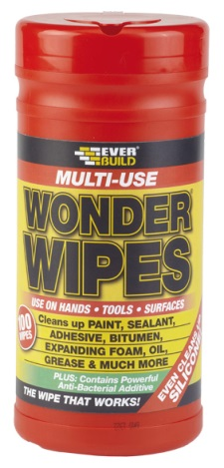

Product Description
EVERBUILD WONDER WIPES are specially formulated for the building and allied trades to clean wet and semi-cured paints, sealants, adhesives, bitumen’s, polyurethanes, expanding foams, polyester fillers and epoxies from hands, tools and surfaces.

Everbuild Wonder Wipes contain a powerful Anti-Bacterial Additive that is tested by an independent laboratory to BS EN 1276:2009 the standard for killing bacteria.
Wonder wipes are active against most common bacteria found in the home and workplace. See independent test reports for full details

WONDER WIPES also easily remove oil, grease petrol and inks, yet the powerful cleaning agents are still kind to hands.

Benefits
- Available in handy 100, 300 and 500 wipe tubs.
- Removes finger marks, dirt, grime, oil, grease, petrol inks, food stains, part cured sealant and paint smears.

Limitations
- Do not use on porous surfaces such as untreated wood.
- Do not dispose of wipes in toilets.
- Use only as directed.
- Store only in original container
- As with all detergents, people with sensitive or damaged skin should avoid prolonged contact with skin.
- It is the users responsibility to determine suitability for use. If in doubt contact technical services department for advice.

Application
100/300/500 wipe size: Pull off lid and open closure. Find start wipe in centre of roll. Pull out approx 1 foot of wipes and thread through lid. Replace lid immediately and reseal closure.

Wipe on hand/spills, use immediately for best results.

Health & Safety
Consult MSDS for full list of hazards.

Storage
Store in cool dry conditions away from direct sunlight between 5 and 25ºC. Storage outside these parameters will significantly reduce shelf life. Ensure good ventilation.

Shelf Life
36 months from date of manufacture

The technical data contained herein is based on our present knowledge and experience and we cannot be held liable for any errors, inaccuracies, omissions or editorial failings that result from technological changes or research between the date of issue of this document and the date the product is acquired. Before using the product, the user should carry out any necessary tests in order to ensure that the product is suitable for the intended application. Moreover, all users should contact the seller or the manufacturer of the product for additional technical information concerning its use if they think that the information in their possession needs to be clarified in any way, whether for normal use or a specific application of our product. Our guarantee applies within the context of the statutory regulations and provisions in force, current professional standards and in accordance with the stipulations set out in our general sales conditions. The information detailed in the present technical data sheet is given by way of indication and is not exhaustive. The same applies to any information provided verbally by telephone to any prospective or existing customer.

